

Area Service Committee Meeting Minutes
June 12, 2025

Date: Jun 12, 2025
Called to order: Paul L.
Time: 7:00pm
Moment of silence followed by the Serenity Prayer.
Could someone please read
  - Twelve Traditions: JJ
  - Twelve Concepts: BRIAN
  - GSR Responsibilities: DERRICK

Roll Call:
- Chair
- Vice Chair
- Secretary
- Alt. Secretary
- Treasurer
- Alt. Treasurer
- RCM
- RCM II
- SE
- PR
- H&I
- Phone Line
- Literature
- Policy
- Website
- Mentor

Total Home Groups: 47
Total GSR’s Present: 26
Voting GSR’s: 24
Quorum: Yes (Need 17)
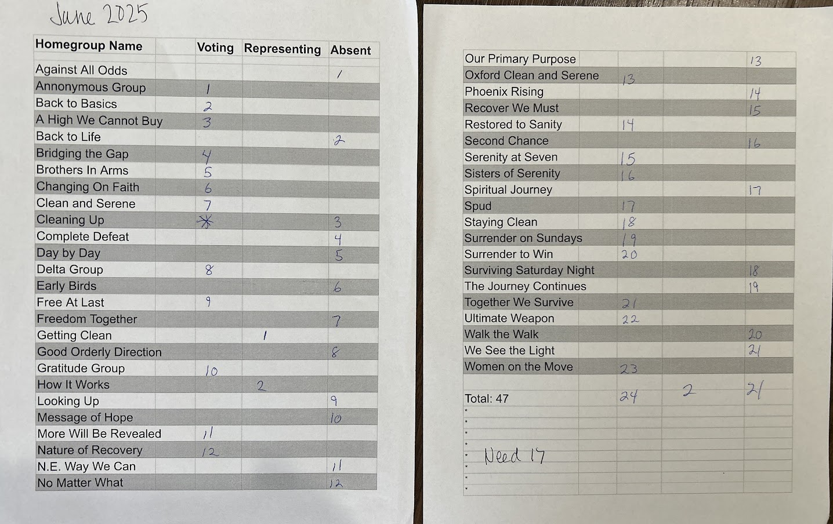

Are there any new GSR’s?
- Yes
- No
If yes, name (s):
Are there any groups wishing to start a new meeting in the area?
- Yes
- No
If yes,
Name: SHANNON
Night: NEVER LOOK BACK
Time: TUESDAY, 7-8PM
Location: 1511 PRINCIPIO FURNACE ROAD, PERRYVILLE

Subcommittee Reports:
PR: Pete
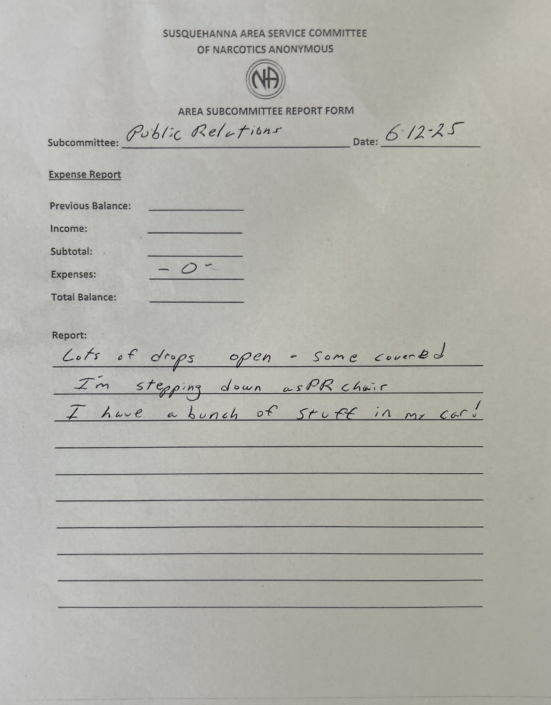
Questions/Discussions: THANKS FOR YOUR SERVICE, PETE!

Phone Line: Danielle
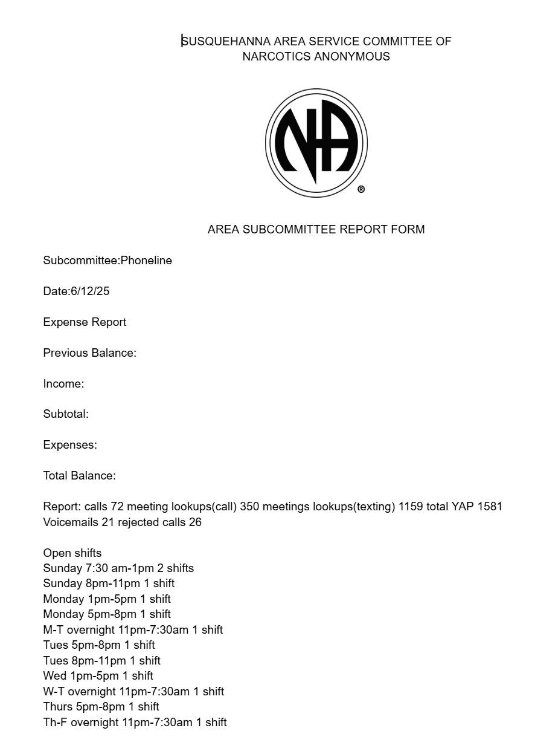

Questions/Discussions: REVIEW OF PHONE SHIFTS AVAILABLE

Literature: Adam
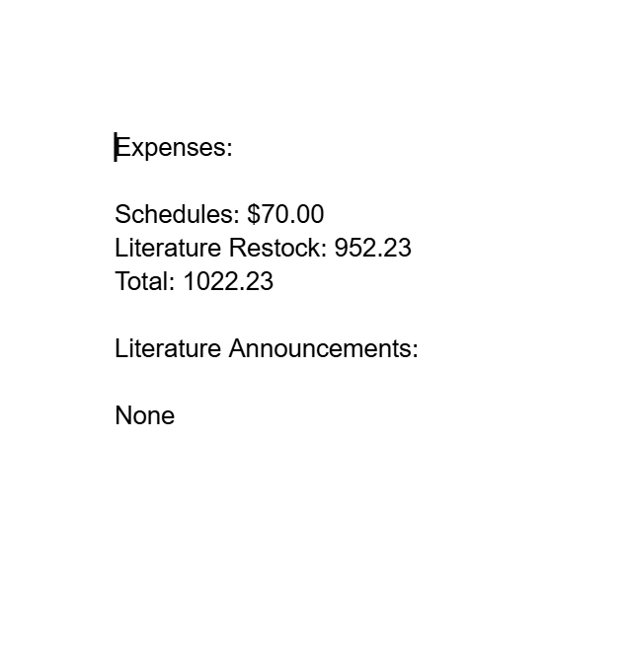
Questions/Discussions: NONE

Special Events: Cole
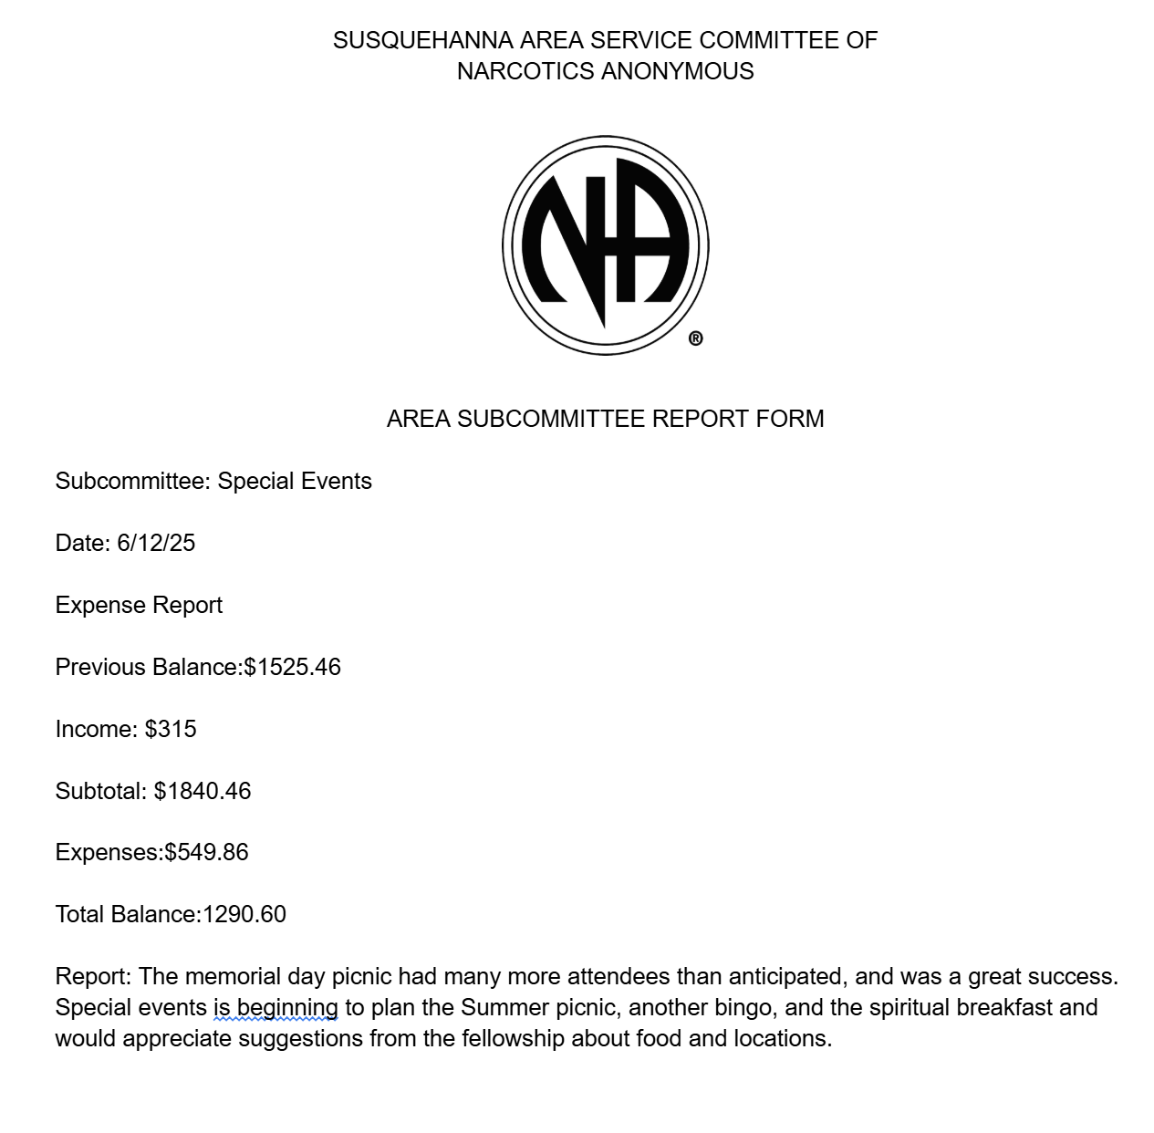
Questions/Discussions: MEMORIAL DAY PICNIC WAS FREE, LEADING TO DEFICIT
REVIEW OF NUMBERS

H&I: Jess
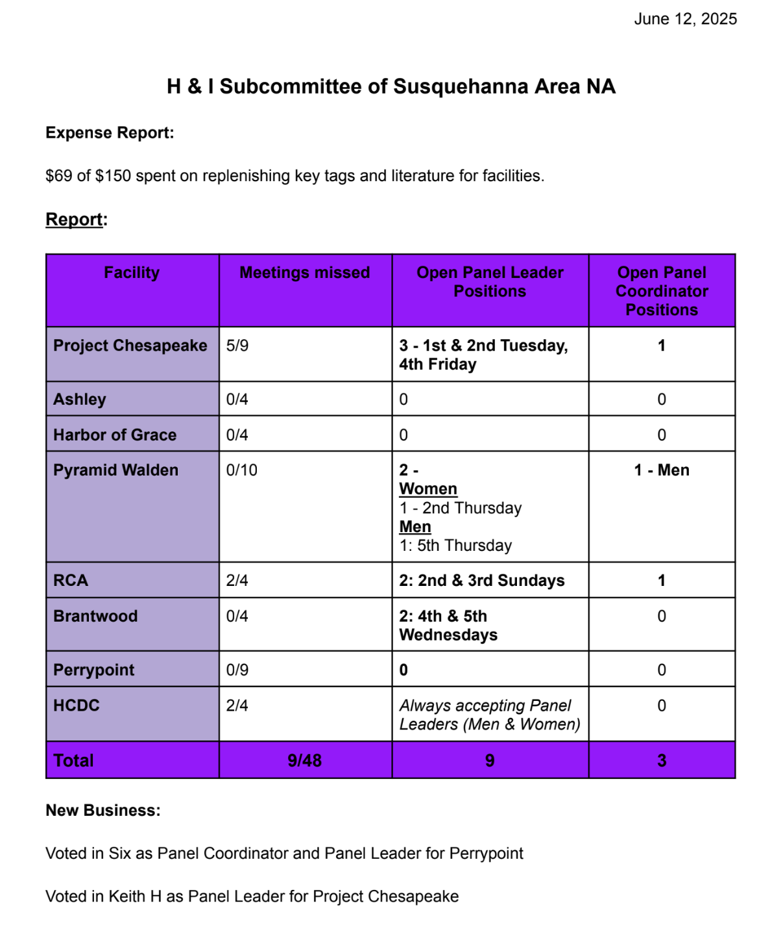
Questions/Discussions:
STEVE: LOCATION OF RCA? CONCERNED OF BYPASSING AREA
JESS NOTED THAT SPEAKERS NEED TO BE CHANNELED TO H&I.
STEVE WILL SEND VOLUNTEERS TO JESS

Website: Kevin
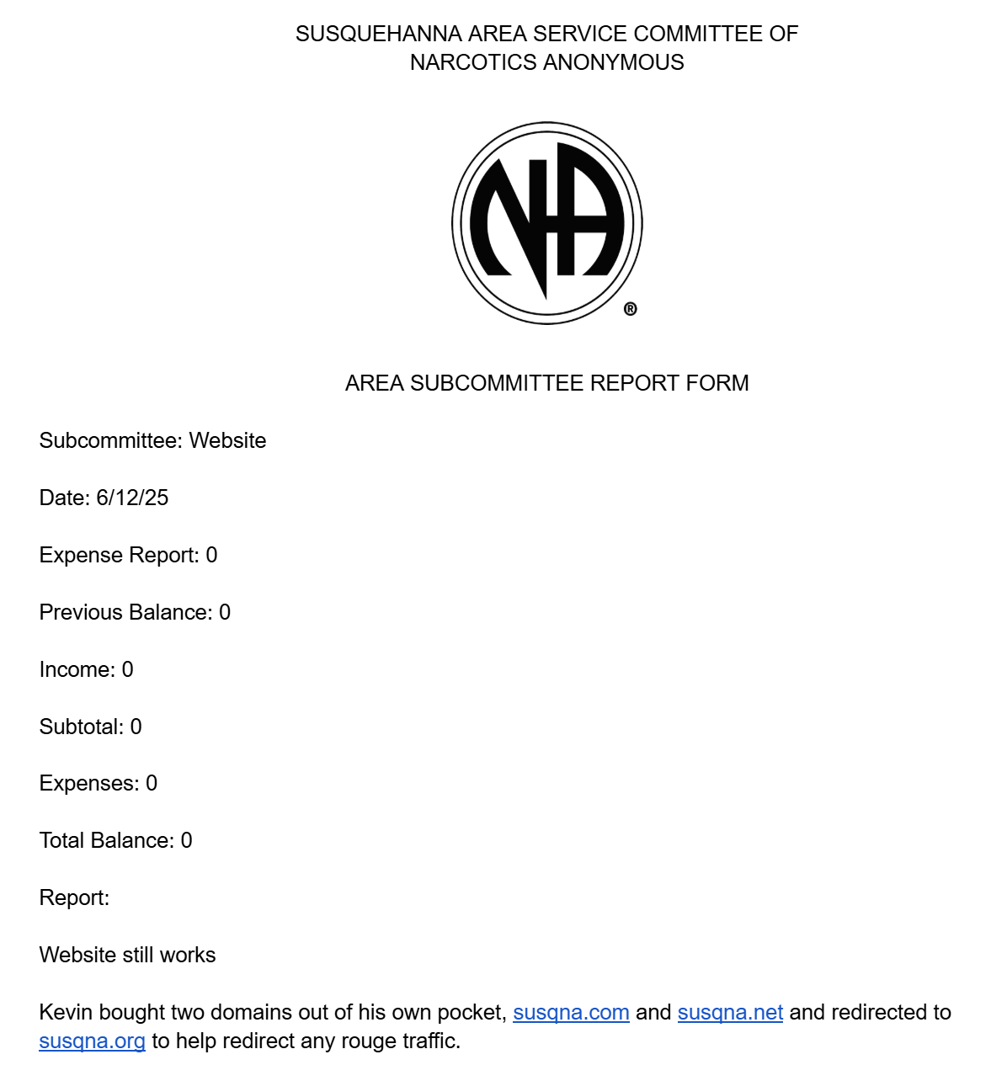

Questions/Discussions:
JJ: UPTICK OR DECREASE OF VISITS TO WEBSITE?
KEVIN: UP 18%
ADAM: ADDITIONAL COST OF .NET AND .COM?
KEVIN: $12.00
MELISSA: VOTE FOR REIMBURSEMENT?
KEVIN: NOT SEEKING REIMBURSEMENT

RCM/RCM II: Jeff

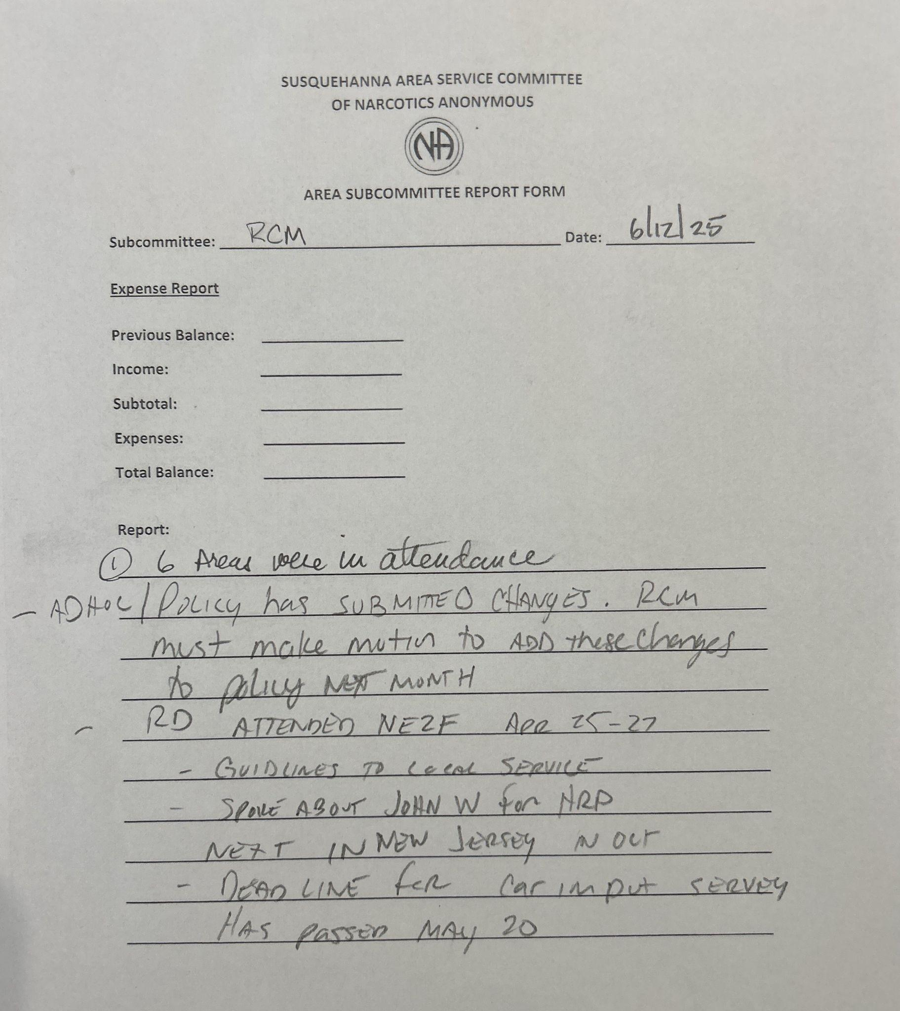

Questions/Discussions:
DERRICK: WHAT WEBSITE HAS THE INFO?
JEFF: FREESTATENA.ORG

Policy: Melissa
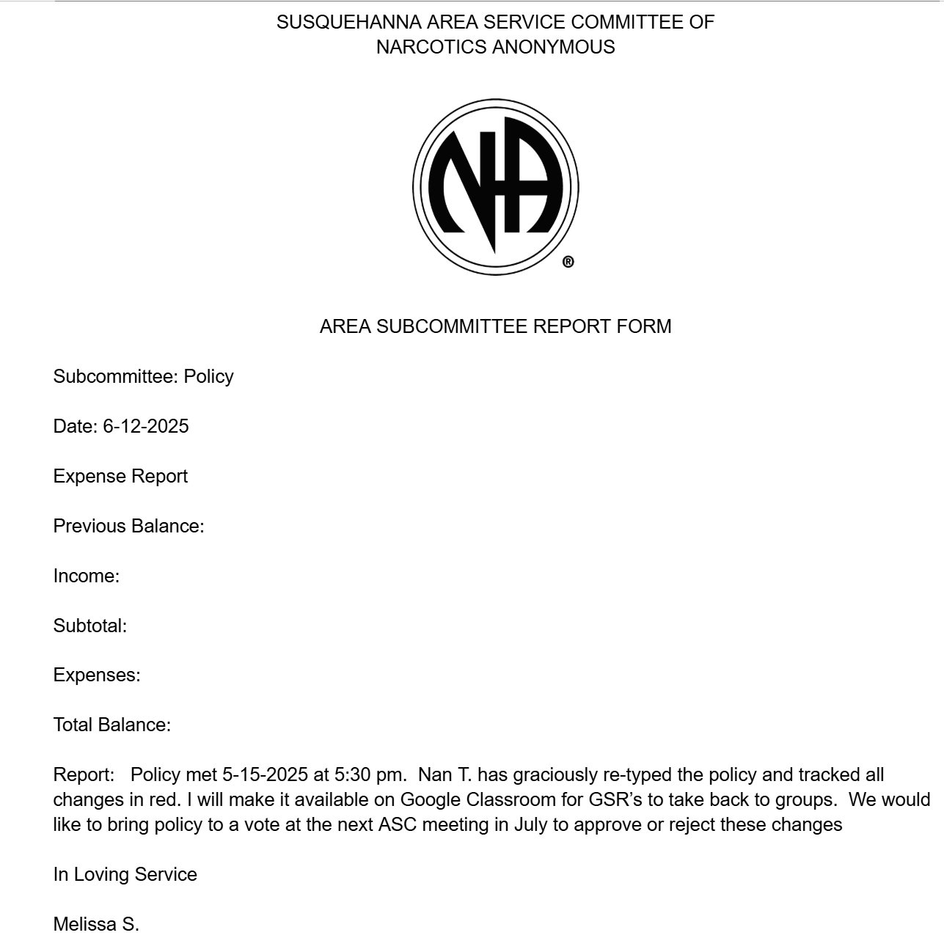
Questions/Discussions:
NAN FOR VICE CHAIR OF POLICY
POLICY WILL BE ATTACHED TO MINUTES

Treasurer: Amanda
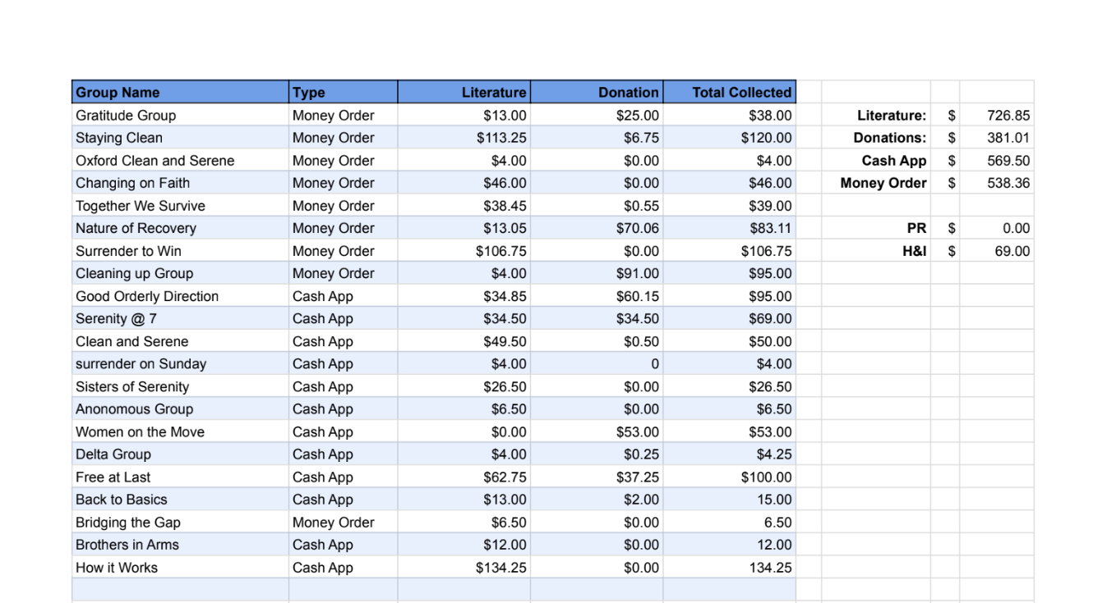
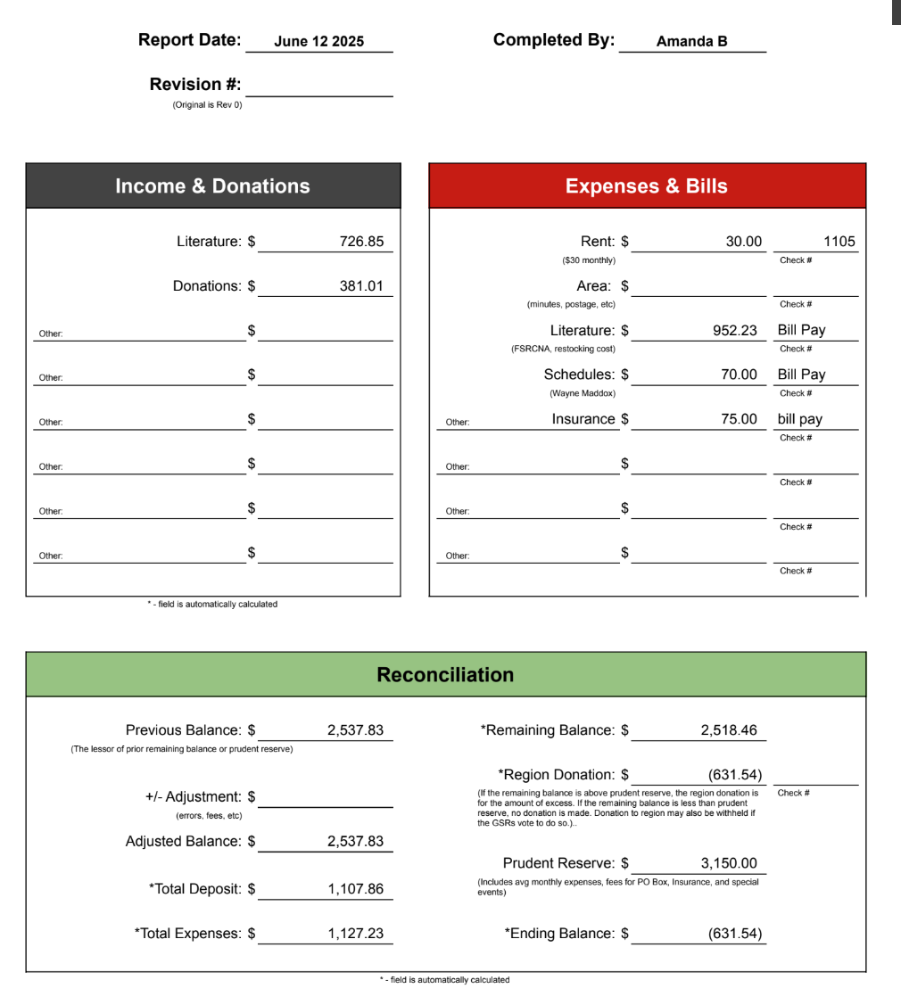

Questions/Discussions:
ELLEN: HOW MUCH IS RENT?
AMANDA: $30
DAVE: WHY DO WE HAVE 3K IN PRUDENT RESERVE?
AMANDA: MAKE A MOTION

Other/Ad Hoc: NONE
Questions/Discussions:

Motion to approve last month's minutes?
Motion: HEATHER
Second: MELISSA

Sharing Session: NONE

Old Business:
KEEP MENTOR RESPONSIBILITIES?
JEFF: IS THERE A MOTION?
HE WILL SUBMIT
MELISSA: WE VOTED. MENTOR POSITION SECURE
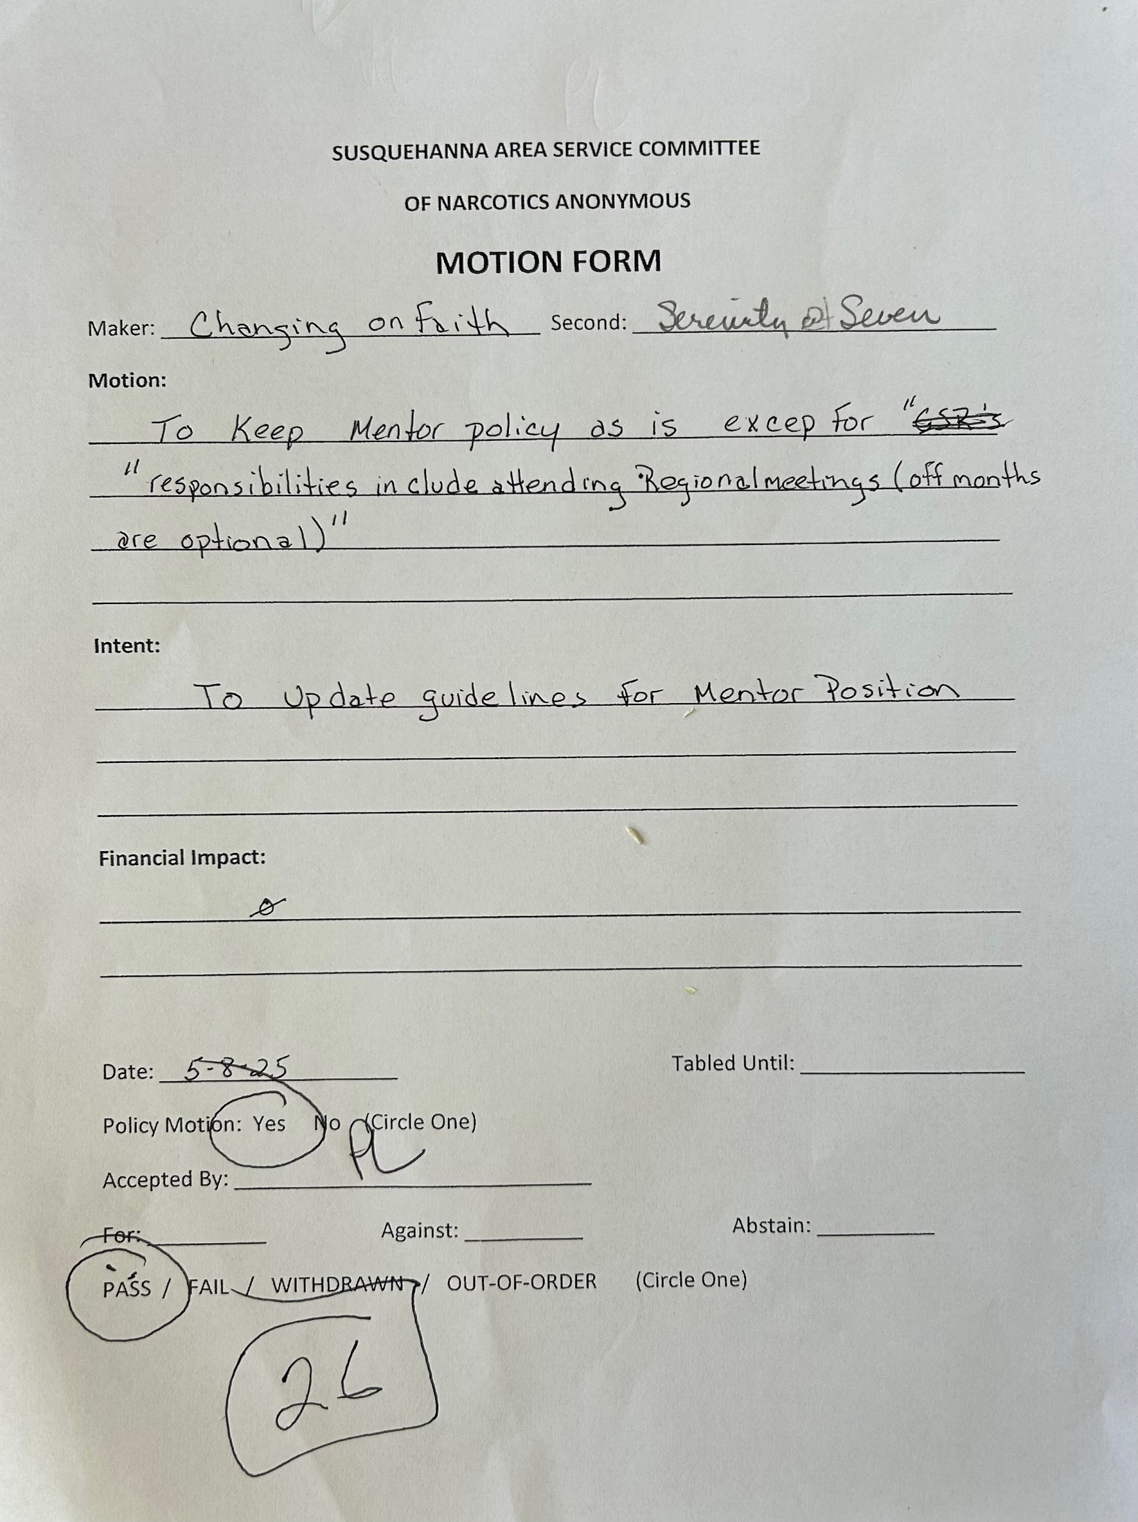

New Business:
- Motion: JEFF H: .NET/.COM
ADDED TO .ORG
FORWARDED TO .ORG
MOTION TO BE PART OF POLICY
COST TO BE ABSORBED IF KEVIN STEPS DOWN
DISCUSSION:
CONS: KEVIN COULD GO SMOKE CRACK AND THEN WHO WOULD PAY?
PROS: IN POLICY IT WILL BE IMPLEMENTED
MELISSA: REWORDED MOTION TO BE MORE CLEAR
PAUL: IF YOU HAVE A MOTION, POLICY WILL HELP YOU WRITE IT UP FOR CLARITY.
SYLVIA: CLARIFICATION, COSTS ABSORBED BY CHAIR? PAID BY AREA IN THE FUTURE?
STEVE: ALERTED FOR PAYMENT HOW?
ARE THERE ALERTS FOR INSURANCE PAYMENTS?
GOES TO WEBSITE
CALL FOR VOTE: DAVE
MOTION PASSED
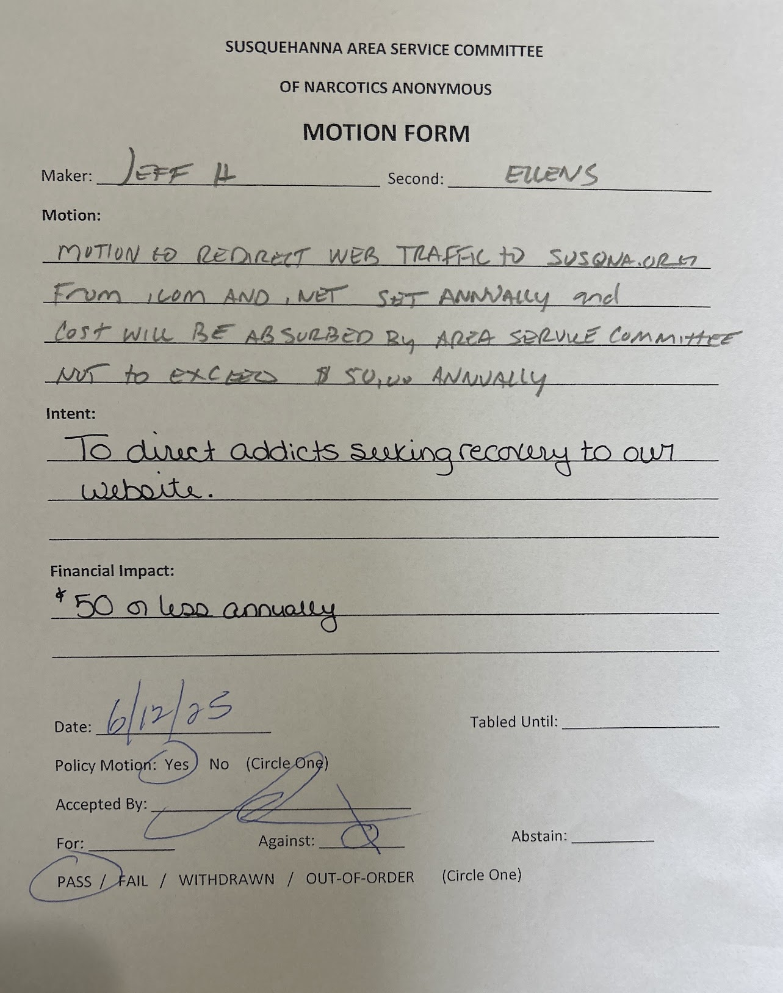
- Nominations:
CHAIR: JEFF H. NOMINATED PAUL L./ACCEPTED
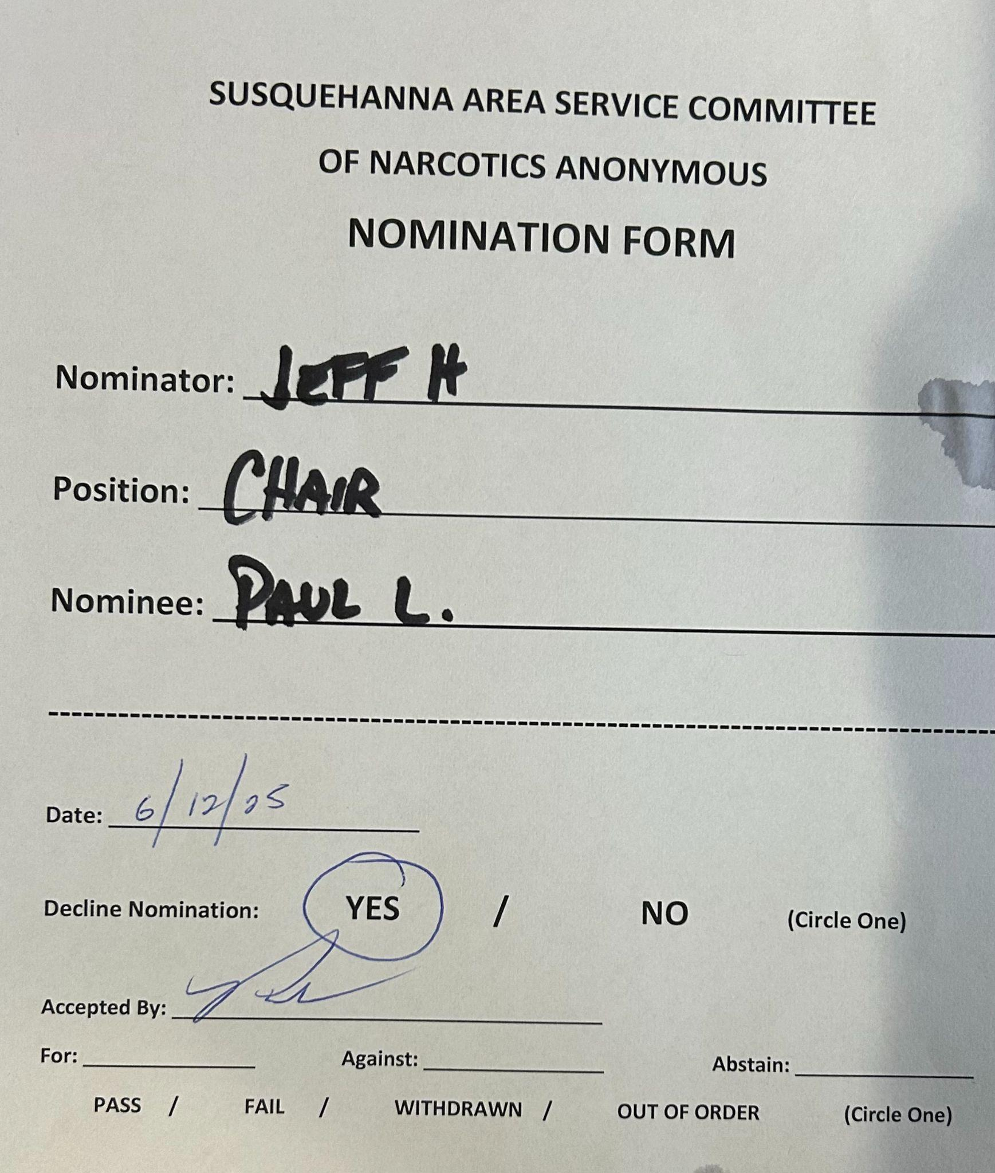

VICE CHAIR: JEN B. NOMINATED JESS N./ACCEPTED
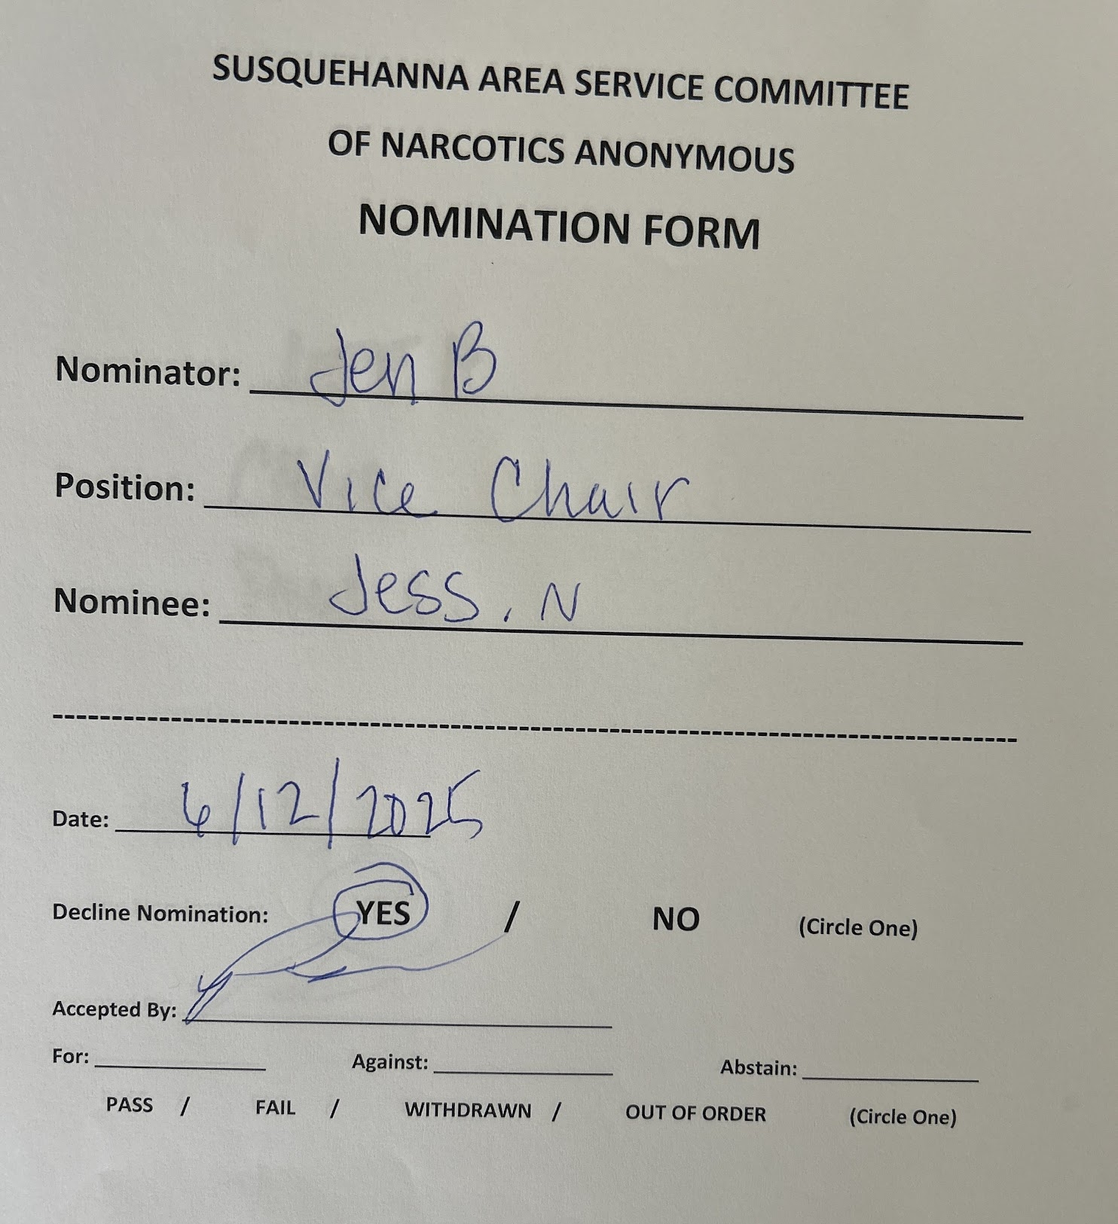
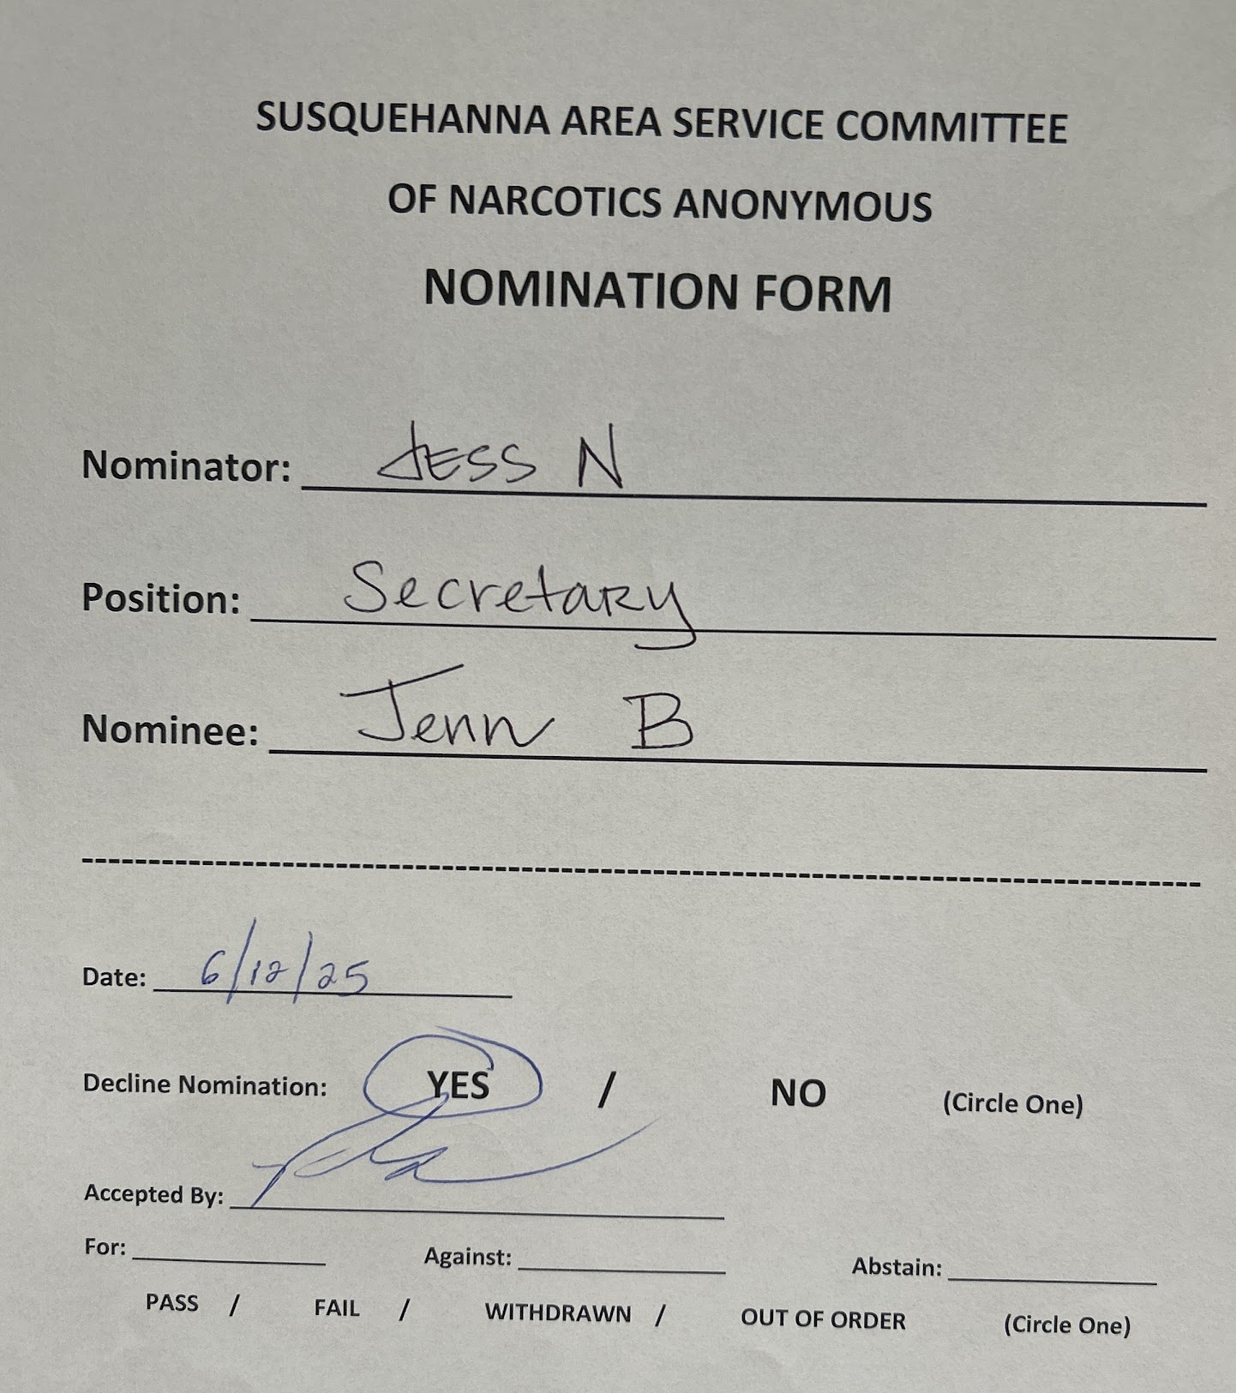
SECRETARY: JESS NOMINATED JEN B./ACCEPTED

ALTERNATE SECRETARY: JESS NOMINATED SHERRY M. /ACCEPTED
(SYLVIA AGREED)
TREASURER: COLE NOMINATED AMANDA B./ ACCEPTED

PHONE LINE: JESS N. NOMINATED DANIELLE D./ACCEPTED
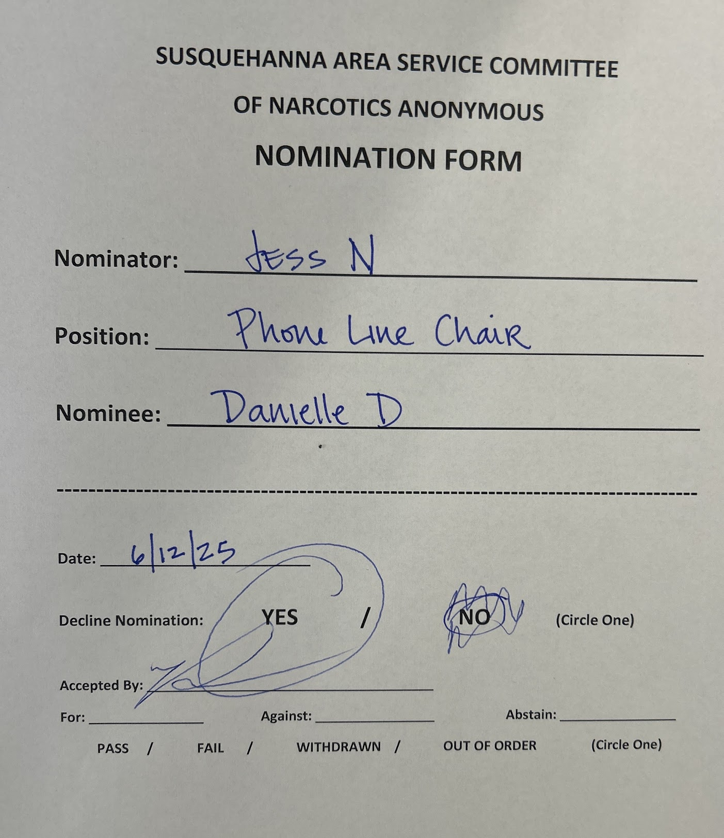
ALT. TREASURER: AIMIE L./ ACCEPTED
SPECIAL EVENTS: COLE NOMINATED/ACCEPTED
PR: NO NOMINATIONS
LITERATURE: ADAM NOMINATED ADRIAN S./ACCEPTED
POLICY: MELISSA S. NOMINATED/ ACCEPTED
WEBSITE: KEVIN D. NOMINATED/ ACCEPTED
MENTOR: JEFF H. NOMINATED/ ACCEPTED
H&I: JESS N. NOMINATED JEFF C./ACCEPTED
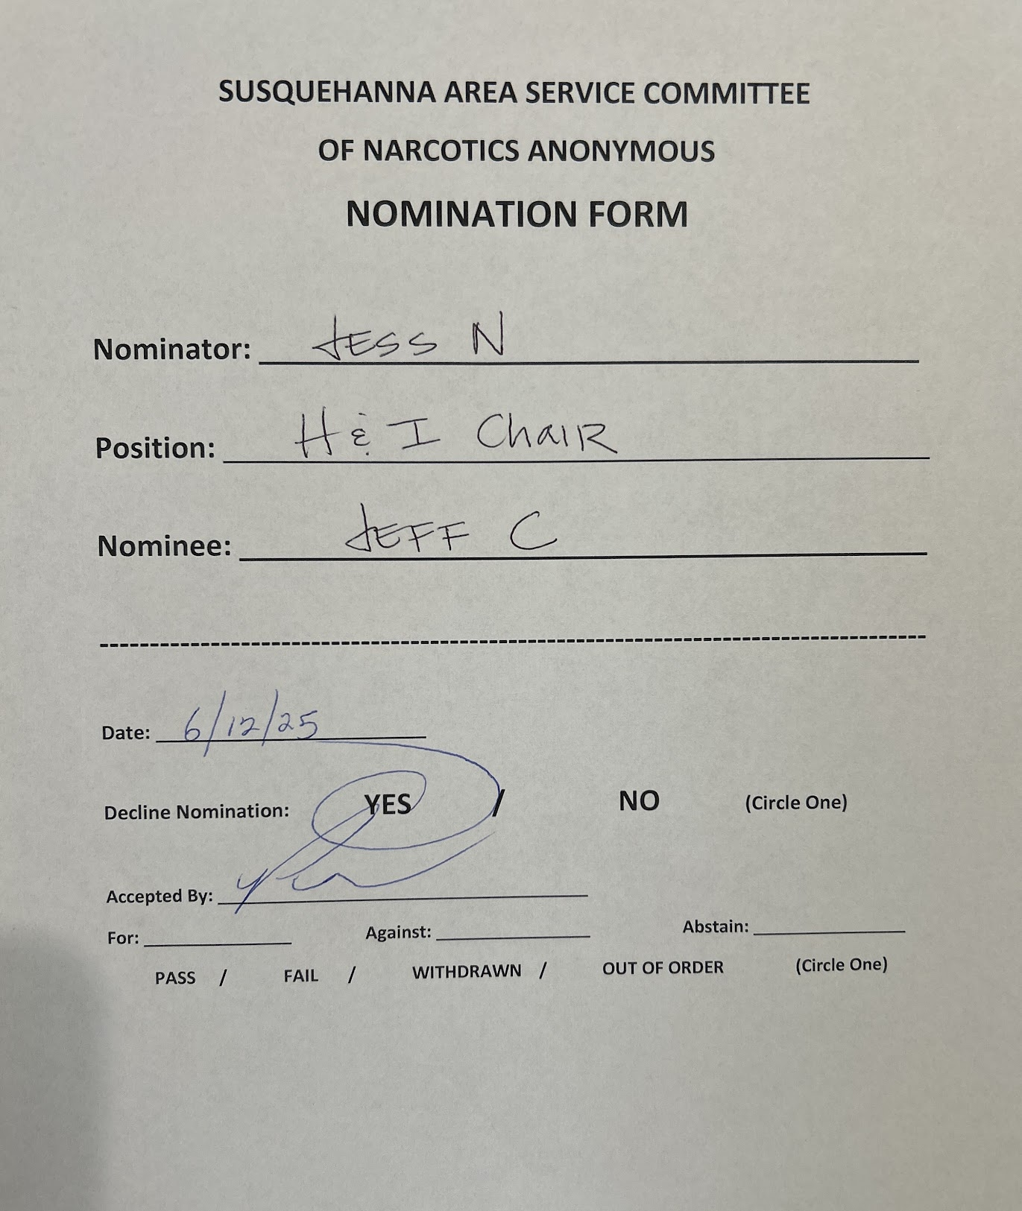

RCM: JEFF H. NOMINATED ELLEN S./ACCEPTED
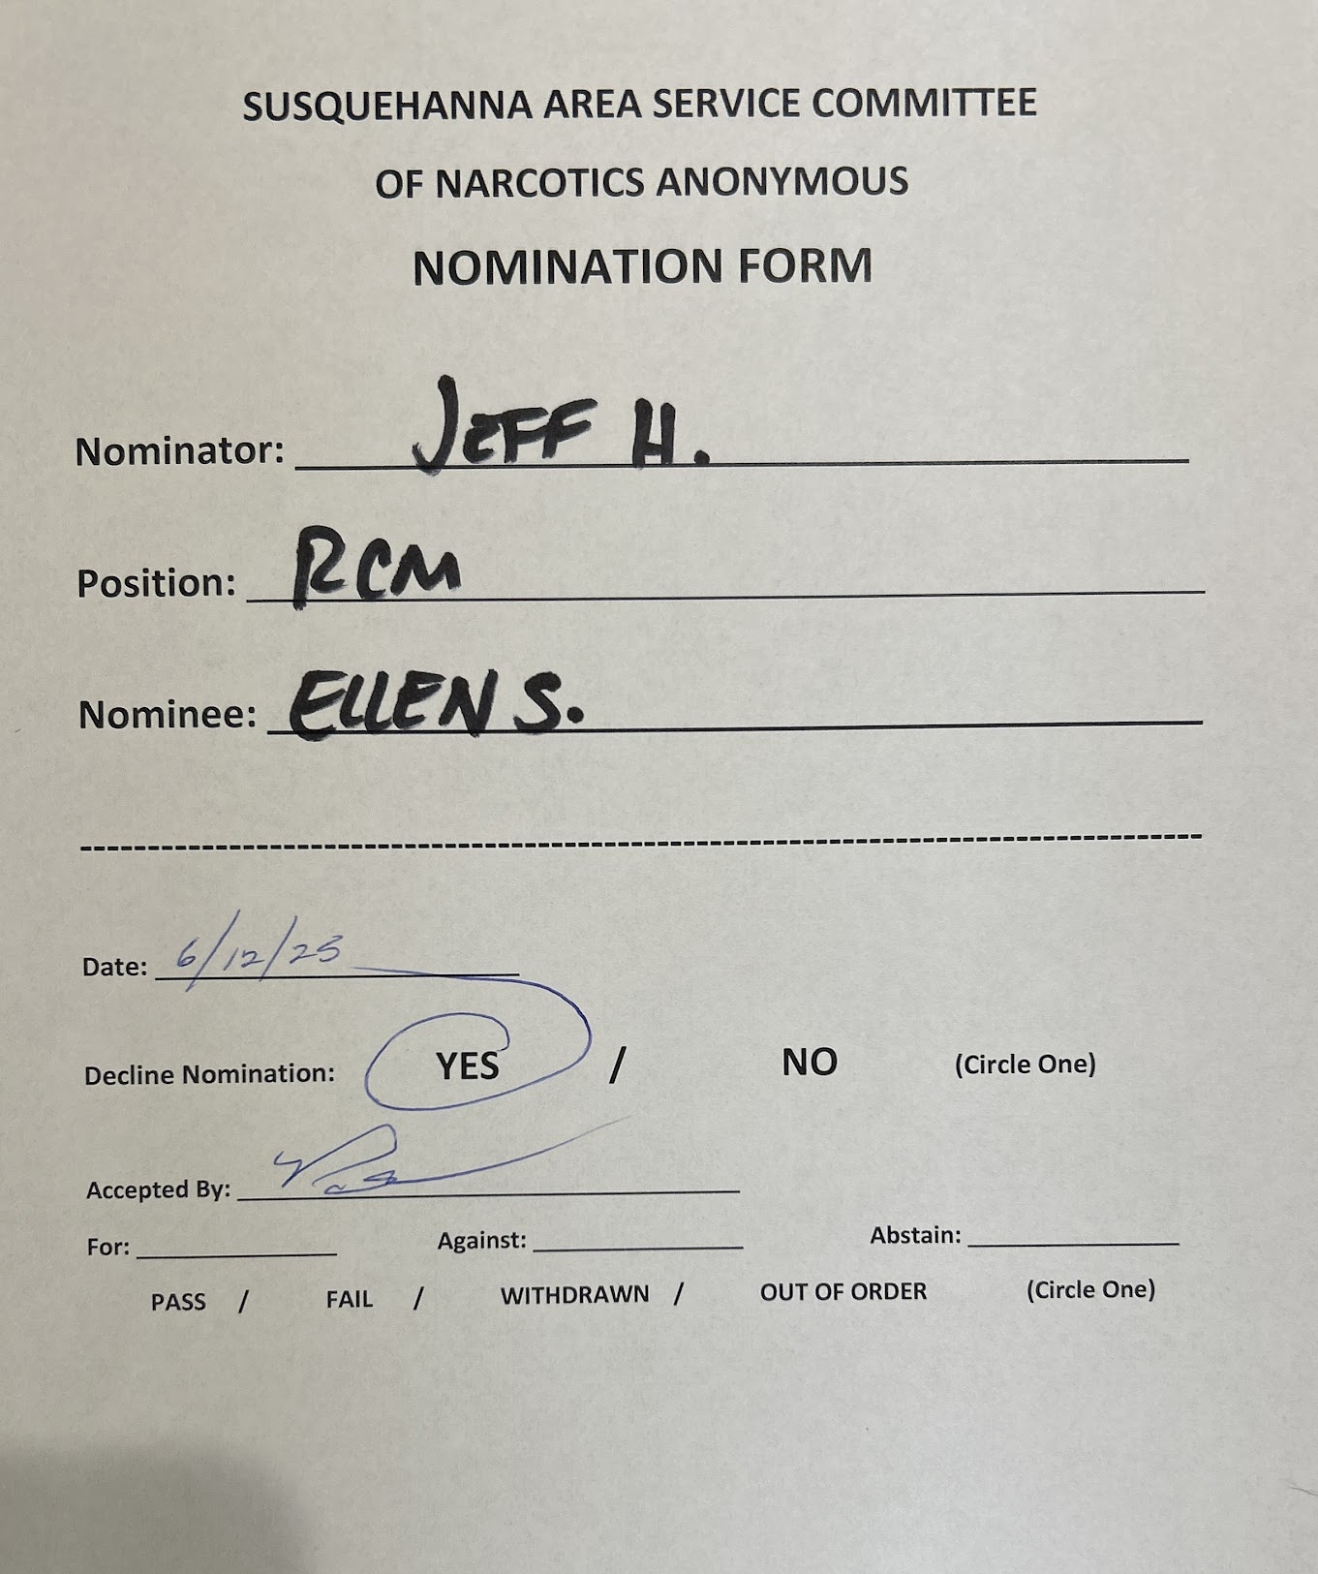
RCM2: ELLEN S. NOMINATED DAVE D./ACCEPTED
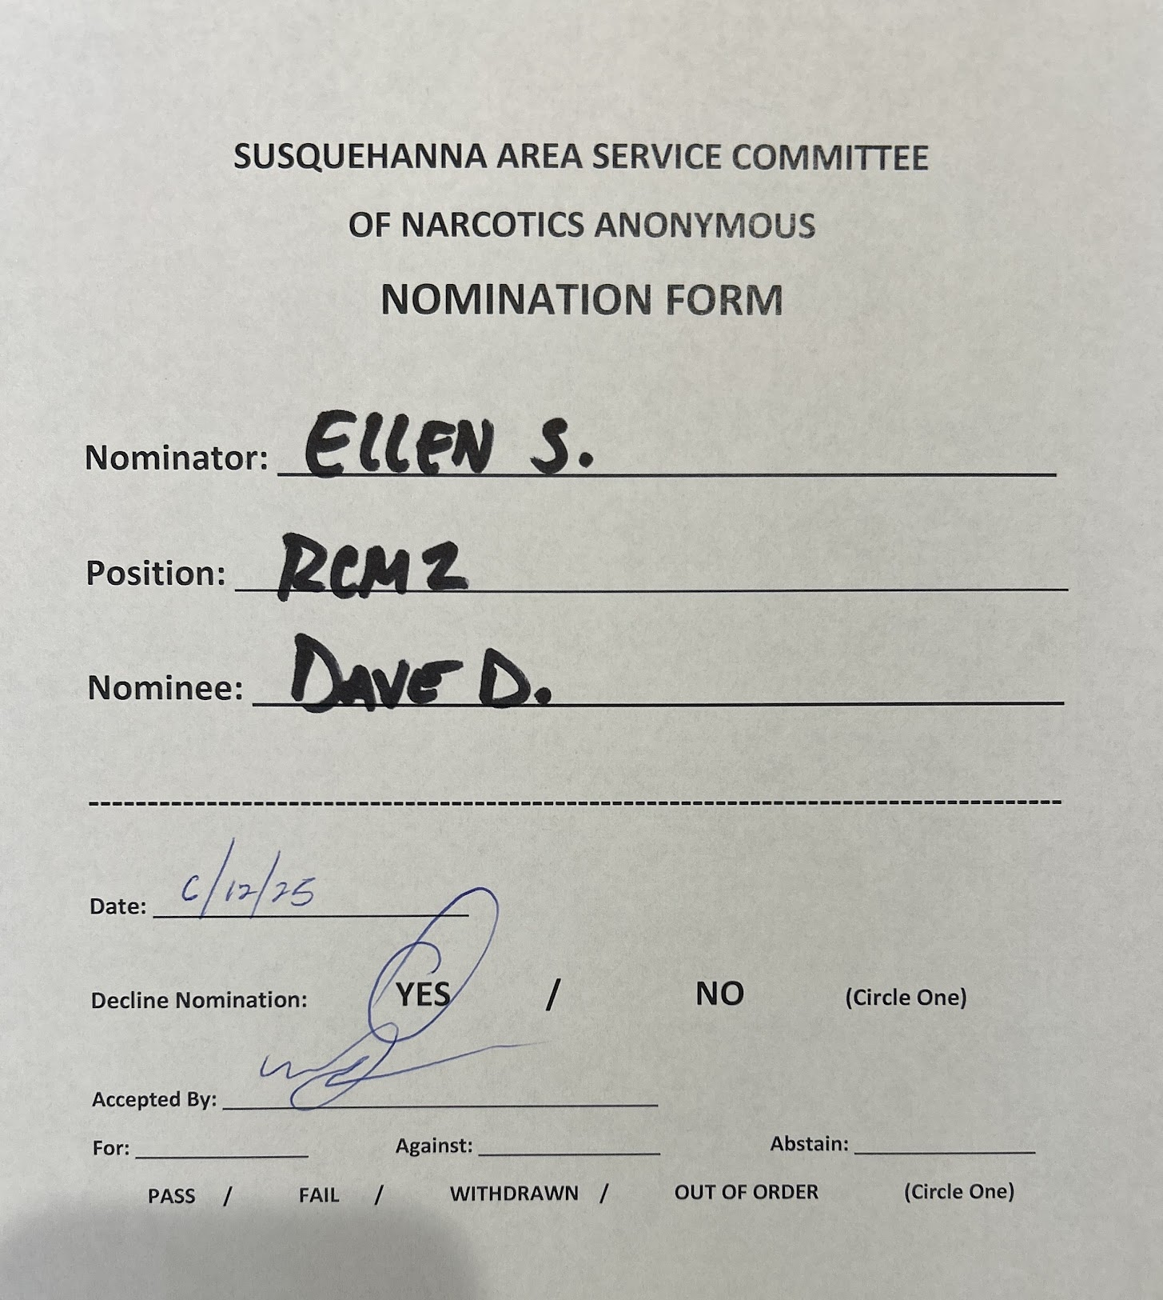
Motion to close: PAUL
Second: HEATHER
Close meeting with Serenity Prayer.
Time Meeting Adjourned: 7:57

If recount of GSR’s needed: n/a
Quorum? 17 (50% of previous 2 months)

Attendance:
P=Present A=Absent V=Voting R=Represented by Vac=Vacant I=Inactive
Executive Body Attendance:
Title | Name | Jun  ‘25 | Jul | Aug | Sep | Oct | Nov | Dec | Jan | Feb | Mar | Apr | May ‘
Chair | Paul L  717-676-8471 | P | P | P | P | P | P | P | P | P | P | P | P
Vice Chair |  |  | P | P | A | P | P | P | P | P | P | A | A
Secretary | Jen B  443-271-2177  jennifer.bridges.g@gmail.com | P | P | P | P | P | P | A | A | P | A | A | A
Alt.  Secretary |  |  |  |  |  |  |  |  |  |  |  | P | P
Treasurer | Amanda B  443-802-3620 | P | A | P | P | P | P | P | P | P | P | P | P
Alt. Treasurer | Aimie L  443-966-1008 | P | P | P | P | P | P | P | P | P | P | P | P

Subcommittee Chair Attendance:
Subcommittee | Name | Jun  ‘25 | Jul | Aug | Sep | Oct | Nov | Dec | Jan | Feb | Mar | Apr | May
RCM | Jeff H  443-903-1772 | P | A | P | P | P | P | P | P | P | P | P | P
RCM II | Ellen S  443-538-6039 | P | P | P | P | A | P | P | A | A | P | P | P
Phone Line | Danielle D  410-322-0484 | P | A | P | P | P | P | P | A | A | A | P | P
Literature | Adam H | P | P | P | P | P | P | P | P | P | P | P | P
Special Events | Coale G  443-981-0325 | P | A | P | P | P | P | P | P | P | P | P | P
H&I | Jess N. 443-252-1576  Nikosmama1208@gmail.com | P | P | P | P | P | P | P | P | P | P | P | A
Website | Kevin D  443-417-7829 | P | P | P | P | P | P | P | A | P | P | P | P
PR | Pete B. 410-688-5352  Petebennett92670@gmail.com | P | A | A | P | P | P | P | P | P | P | A | P
Policy | Melissa S | P | A | P | A | P | A | P | P | P | A | P | P

Monthly Group Attendance:
Group Name | Jun  ‘25 | Jul | Aug | Sep | Oct | Nov | Dec | Jan | Feb | Mar | Apr | May
A High We Cannot Buy | V | V | V | V | V | V | V | V | V | V | V | V
Against all Odds | A | R | R | A | A | A | A | V | A | R | V | V
Anonymous Group | V | V | V | V | V | V | V | V | V | V | V | V
Back to Basics | V | A | A | A | A | A | V | A | A | R | V | V
Back to Life | A | V | V | R | R | A | A | R | A | R | A | A
Bridging the Gap | V | V | V | V | V | R | A | V | V | A | A | V
Brothers in Arms | V | V | V | V | V | R | V | V | V | V | V | V
Changing on Faith | V | V | V | V | V | V | V | V | V | V | V | V
Clean and Serene | V | V | V | V | V | V | V | V | V | V | V | V
Cleaning Up | V | V | V | R | R | R | V | R | A | V | A | R
Complete Defeat | A | V | V | V | R | V | V | A | V | A | V | A
Day by Day | A | A | A | A | A | A | A | A | A | V | V | V
Delta Group | V | V | V | A | A | V | V | V | V | V | R | V
Early Birds | A |  |  |  |  |  | A | A | A | A | A | A
Free at Last | V | V | V | V | V | V | V | V | A | V | V | V
Freedom Together | A | A | A | A | A | A | A | A | A | V | V | V
Getting Clean | R | A | A | A | R | R | R | A | A | R | R | A
Good orderly Direction | A | V | A | V | V | R | V | V | R | V | V | A
Gratitude Group | V | V | V | A | V | V | R | V | A | V | V | V
How it Works | R | A | V | V | R | V | A | V | V | V | R | V
Looking Up | A | R | R | R | R | R | A | A | R | R | V | V
Message of Hope | A | A | A | A | A | A | A | A | A | V | V | A
More Will Be Revealed | V | V | V | V | V | A | V | V | R | V | A | A
Nature of Recovery | V | A | V | V | V | V | V | V | V | V | A | V
NE Way we Can | A | A | A | A | A | R | A | A | A | A | A | A
No Matter What | A | A | A | A | A | A | A | A | A | A | A | A
Our Primary Purpose | A | A | A | A | A | V | A | A | A | A | A | A
Oxford Clean and Serene | V | A | V | V | V | V | V | A | V | V | A | V
Phoenix Rising | A | A | V | A | A | A | A | A | A | A | A | A
Recover We Must | A |  |  |  |  |  |  |  | NEW | V | V | V
Restored to Sanity | V | V | V | V | V | A | A | V | A | V | V | A
Second Chance | A |  |  |  |  |  |  |  |  |  |  | A
Serenity at 7 | V | V | V | V | A | V | V | A | A | V | V | V
Sisters of Serenity | V | R | R | V | V | R | V | A | V | V | R | R
Spiritual Journey | A | A | A | A | A | A | A | A | A | A | A | A
SPUD | V |  |  |  |  |  |  |  | NEW | V | V | V
Staying Clean | V | V | V | V | V | V | V | V | V | V | V | R
Surrender on Sunday | V | NEW | R | V | R | R | V | A | V | V | V | V
Surrender to Win | V | V | V | V | V | V | V | A | A | V | A | A
Surviving Sat. Night | A | V | V | V | V | V | V | A | V | V | V | V
The Journey Continues | A | A | A | A | A | A | A | A | V | A | A | R
Together We Survive | V | V | A | R | A | V | V | V | V | V | A | V
Ultimate Weapon | V | V | V | V | R | V | V | V | V | V | V | V
Walk the Walk | A | A | A | V | A | A | V | A | A | A | A | A
We See the Light | A | A | A | V | A | A | A | A | A | A | R | V
Women on the Move | V | A | V | V | V | V | A | V | V | V | V | V
 | Jun  ‘25 | Jul | Aug | Sep | Oct | Nov | Dec | Jan | Feb | Mar | Apr | May
Total Groups | 47 | 42 | 43 | 43 | 44 | 44 | 47 | 46 | 44 | 44 | 47 | 47
Total Attendance | 26 | 16 | 22 | 26 | 20 | 29 | 26 | 21 | 19 | 32 | 29 | 31
Voting GSRs | 24 | 11 | 21 | 22 | 18 | 25 | 23 | 19 | 17 | 28 | 24 | 27
QUORUM | Y | Y | Y | Y | Y | Y | Y | Y | Y | Y | Y | Y

In Loving Service,
Jen Bridges

